**Gym:** [Emerald City Athletics, Everett](https://emeraldcityathletics.com/clubs/everett/) (11/12/20)

**Trainer:**  Calum

# Fitness Plan

Form 5 days/week lift & cardio, daily fitness if possible

Target Establish motion & begin routine, grow strength

Idea 7-days a week, off days are cardio w/gap lifts interspersed (15m/set/…)

Flow 60min lift, 15-30min cardio

Sched Mon Full Body

Tues Legs

Thurs Upper Body

Fri Full Body

Sat Isolation Focus, legs/abs/etc. – “Fun day”

@plan Supersets where applicable, follow form from Calum

# Sets

**Monday – Full Body**

1. Deadlift 3x12
2. Bar Military Press 3x12
3. Burpee / Face Pulls / Kettlebell swings 3x12
4. Kettlebell Squat / Kettlebell Lunge 3x12

**Tuesday - Legs**

1. Leg Press 15(L)/11(M)/10(H)/8(XH)/15(L)
2. Barbbell Lunge 3x12
3. Bulgarian Split Squat / Single-Leg Romanian Deadlift 3x12
4. Machine Leg Extension 3x12
5. Skater Squat 3x15
6. Kettlebell Press Out 3x12

**Wednesday- Rest**

1. Or cardio + torso lift

**Thursday- Upper Body**

1. Chest Press 3x12
2. Renegade Row 3x15
3. Dumbbell Biceps Curl 3x12
4. Cable Triceps Pushdown / Kettlebell Incline Fly / Machine Lateral Raise 3x12
5. Bosu Russian Twist 3x20

**Friday – Full Body**

1. Clean & Jerk / Side Plank Row 3x12
2. Dips / Crab Walk / Wall Ball 3x15
3. Raised Knee Pullups 3x12
4. Dumbbell Lunge to Press 3x12

**Saturday - Isolation**

1. Weighted Situps / Calf Raise 3x12
2. Machine Leg Extension / Recovery Lift / Back Raise 3x12
3. Nordic Hamstring Curl / Dumbbell Row Kickback 3x12

**Sunday – Rest**

1. Or cardio + Shoulder Lift

# Muscle Summary

**Monday – Full Body**

**Tuesday – Legs**

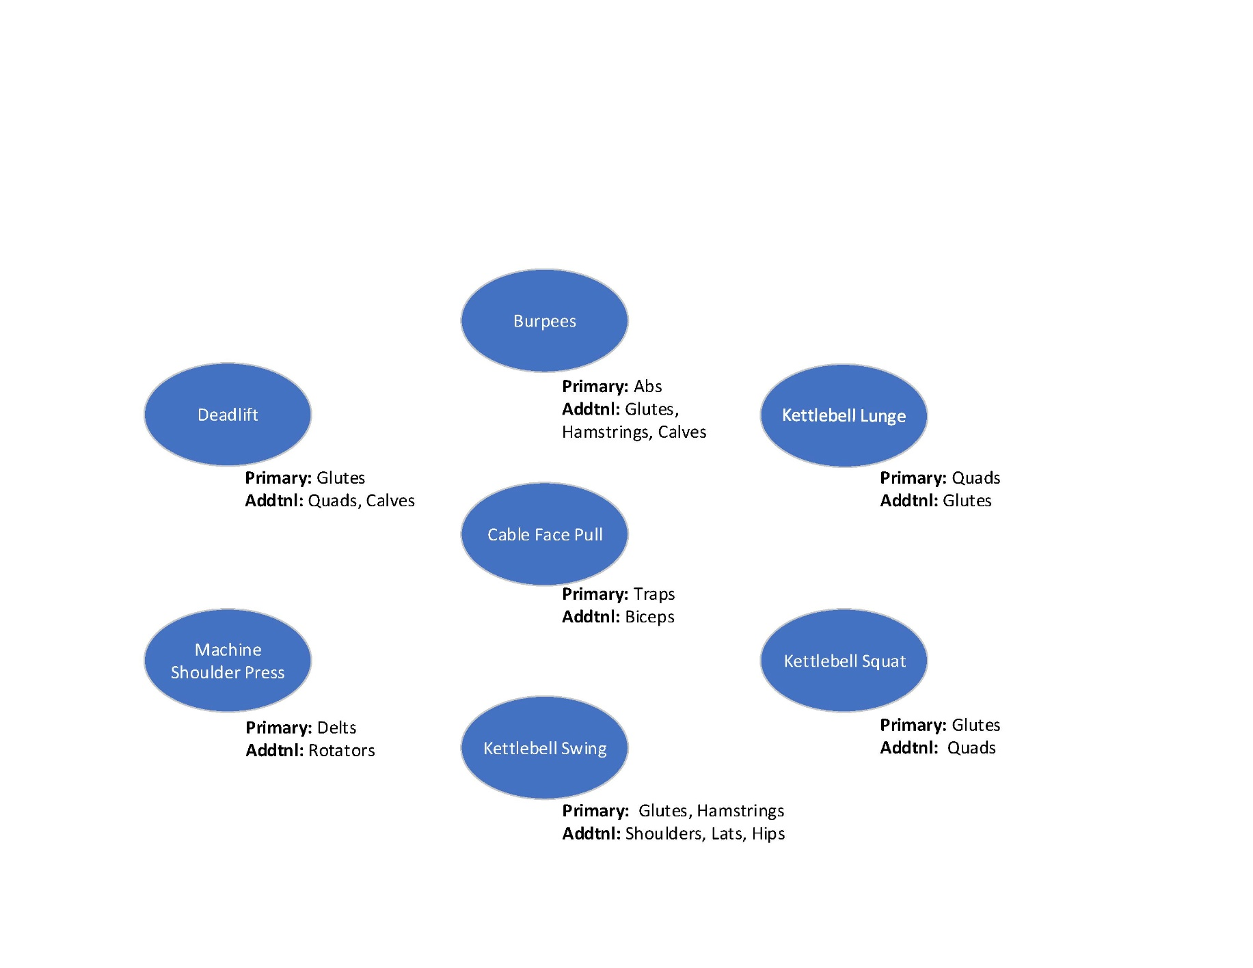

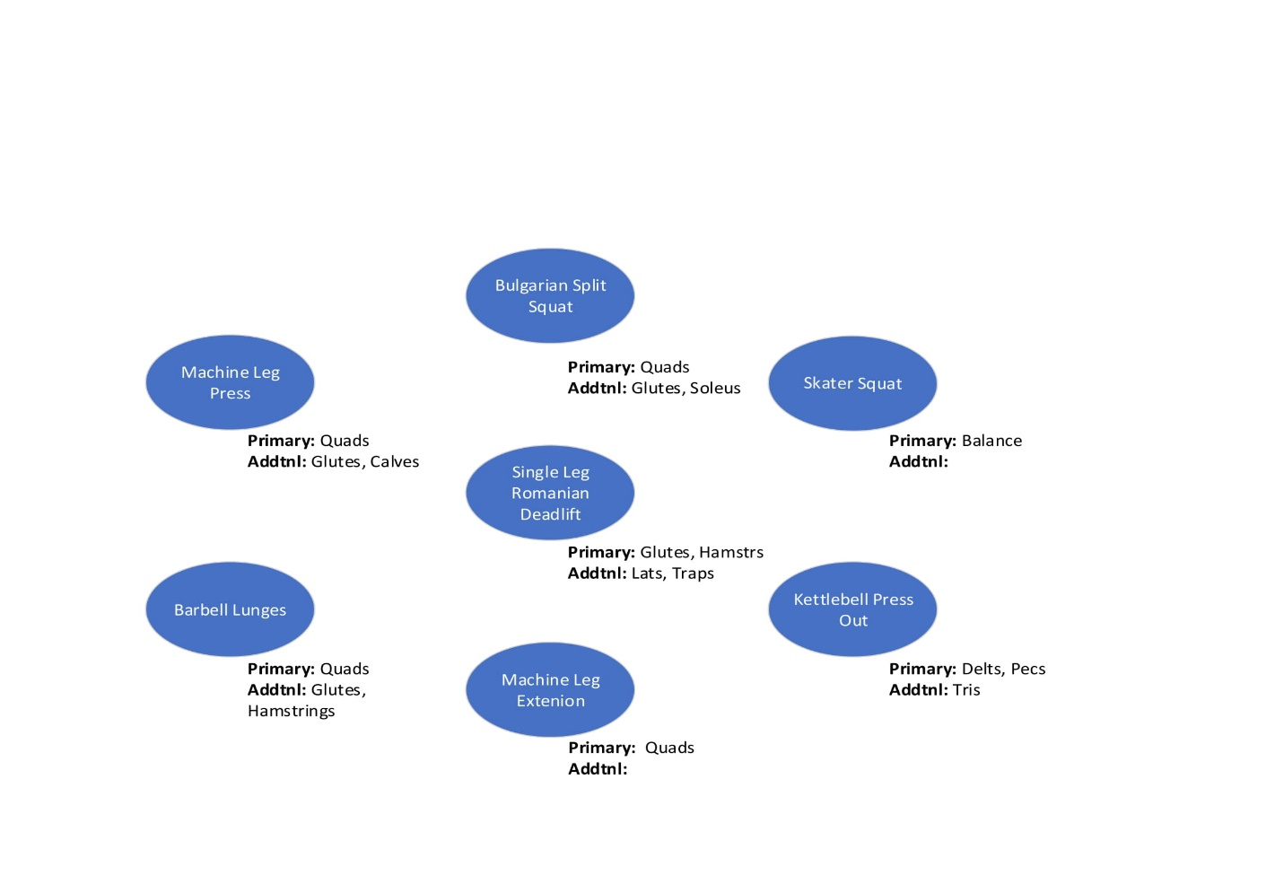

**Friday – Full Body**

**Thursday – Upper Body**

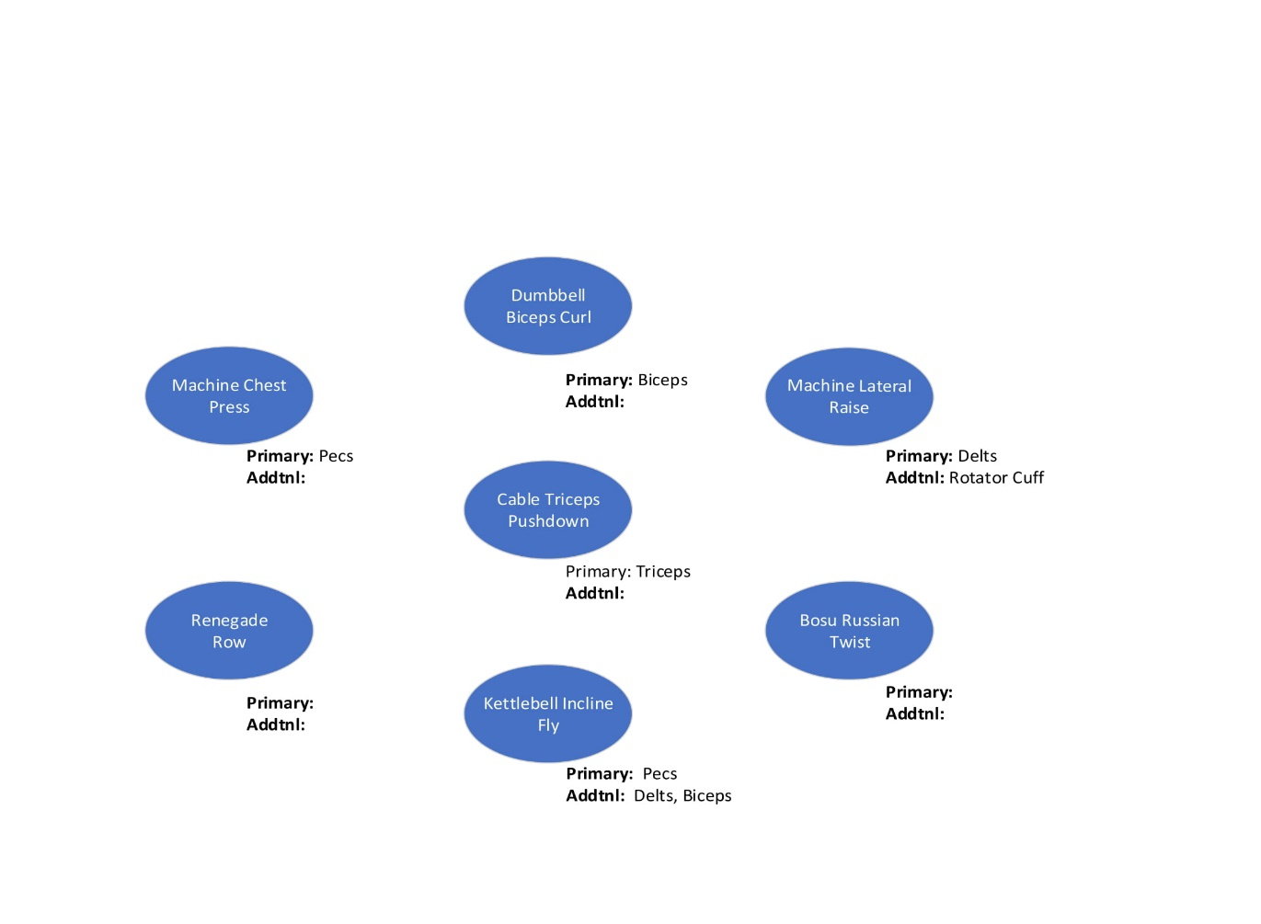

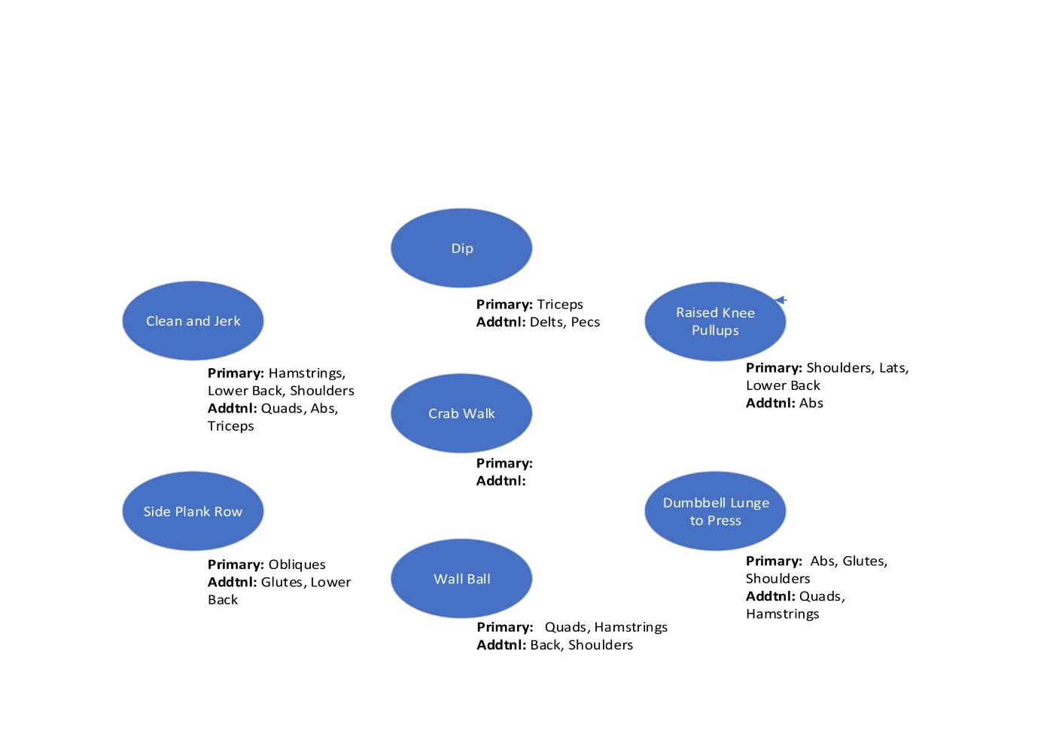

**Friday – Full Body**

**Saturday – Isolation**

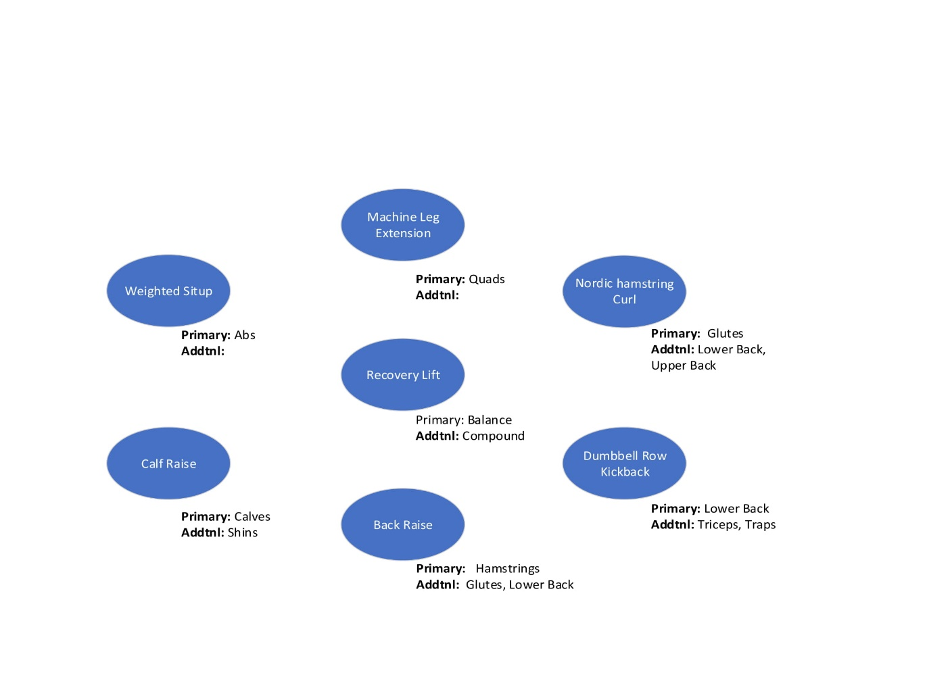

# Lifts

**Wednesday – Torso Supplement:**

Side-Bend-Thing (12) + Wheel Roll-out + Decline Weighted Crunch (12)

15m cardio / 1 set / 15m cardio / 1 set / 15m cardio / 1 set / 15m cardio

**Sunday – Shoulder Supplement:**

Shrugs (12) + Farmers Carry (12)

15m cardio / 1 set / 15m cardio / 1 set / 15m cardio / 1 set / 15m cardio

**Recovery Lifts:**

Incline Treadmill – Reverse Walk

Treadmill Knee Drops

Treadmill Fixed Crawl

Treadmill Climb

**Reference:**

1. [7 Moves You Should Avoid in Your Arm Workouts](https://www.muscleandfitness.com/workouts/arm-exercises/7-moves-you-should-avoid-your-arm-workouts/) - Muscle & Fitness